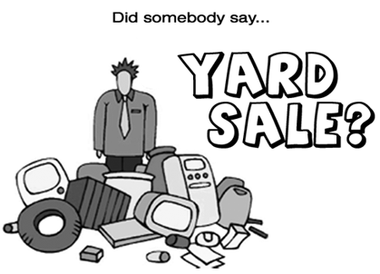

We did! We at 2329 N. Connecticut are having a Yard Sale
on Sat, Aug 27th, from 9am-4pm, and we’re inviting you to
have one as well and make this a BLOCK SALE!

Have you been putting off having one all summer? Well here’s
your motivation to have one that Saturday with your neighbors!

The more sales on one block, the better the turnout!
It’s easy and doesn’t cost anything.

Hope to see you out!

